The 4 Gospels

Matthew’s Gospel

Some sayings of Jesus recorded in Matthew’s Gospel from today’s reading

How does this relate to us personally?

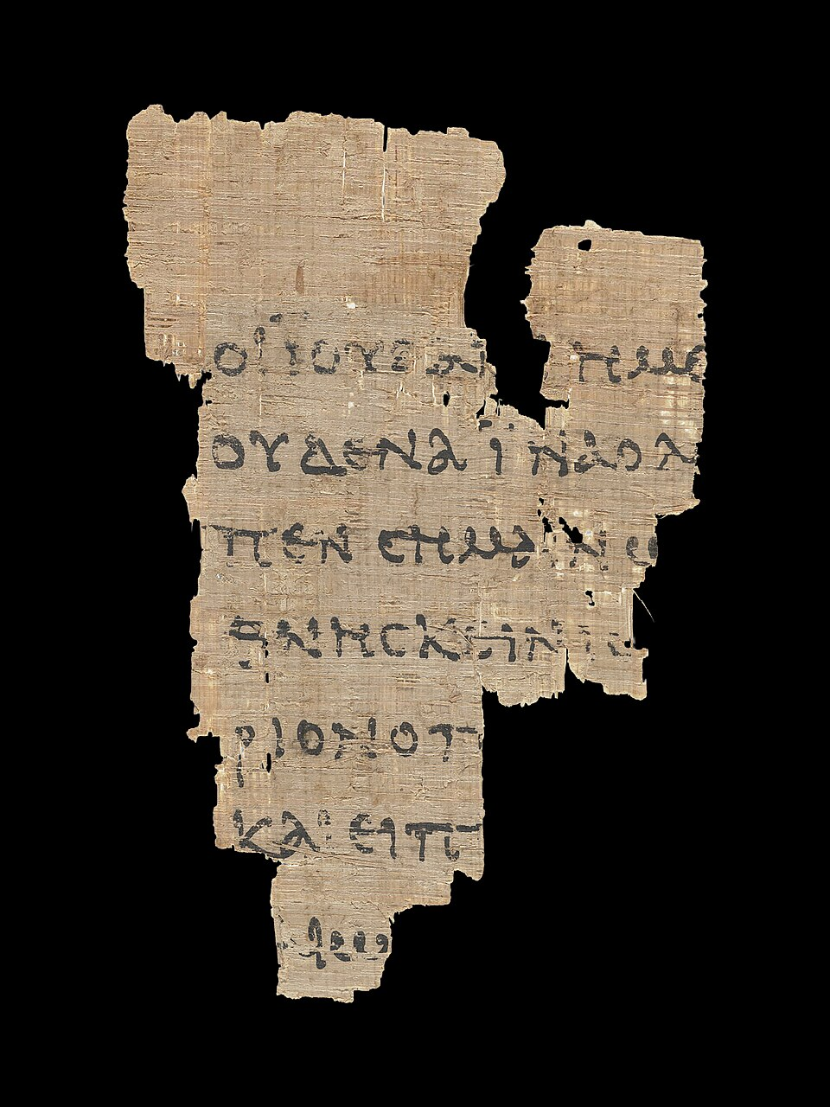

Put the teacher (Jesus) first

Take care about who you choose to follow

Don’t be afraid of opposition

In the end the truth will be revealed

Your soul is more important than your body

Shun evil

You are of infinite value

Do not be afraid

